**Introduction to ai robotics**

**Name: Girish S Roll No: AM.EN.U4AIE22044**

# **Labsheet – 2**

**____________________________________________________________________________________________________**

1. **Rotate a triangle placed at A(0,0), B(1,1) and C(5,2) by an angle 45 with respect to point P(-1,-1). Plot the points.**

clear all;

close all;

A = [0; 0];

B = [1; 1];

C = [5; 2];

P = [-1; -1];

Triangle = [A B C A];

plot(Triangle(1, :), Triangle(2, :), '-go', 'DisplayName', 'Original Triangle');

hold on;

% Rotation matrix

R = [cosd(45) -sind(45); sind(45) cosd(45)];

% Translation to Frame P

A1 = A - P;

B1 = B - P;

C1 = C - P;

% Rotation

A2 = R * A1;

B2 = R * B1;

C2 = R * C1;

% Translate back to World Frame

A3 = A2 + P;

B3 = B2 + P;

C3 = C2 + P;

Triangle2 = [A3 B3 C3 A3];

plot(Triangle2(1, :), Triangle2(2, :), '-ro', 'DisplayName', 'Rotated Triangle');

plot(P(1), P(2), 'r*', 'DisplayName', 'Point P');

axis equal;

grid on;

legend();

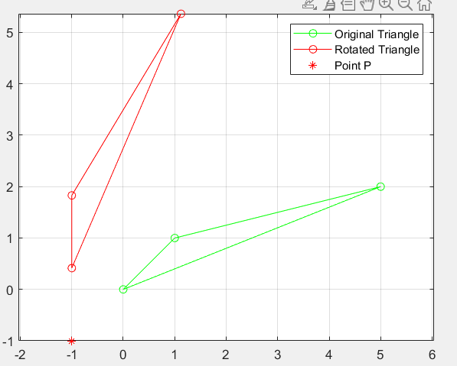

1. **Rotate a triangle placed at A(0,0), B(1,1) and C(5,2) by an angle 45 with respect to origin. Plot the points**

clear all;

close all;

A = [0; 0];

B = [1; 1];

C = [5; 2];

Triangle = [A B C A];

plot(Triangle(1, :), Triangle(2, :), '-go', 'DisplayName', 'Original Triangle');

hold on;

% Rotation matrix

R = [cosd(45) -sind(45); sind(45) cosd(45)];

% Rotation

A1 = R * A;

B1 = R * B;

C1 = R * C;

Triangle2 = [A1 B1 C1 A1];

plot(Triangle2(1, :), Triangle2(2, :), '-ro', 'DisplayName', 'Rotated Triangle');

axis equal;

grid on;

legend();

